**Round 3 -Lab Manual**

|  |
| --- |
| **Name of Faculty:** Mr.Praveen Goyal  **Institute:**  Rajkiya Engineering College,Banda  **Email ID**  **:**  praveen_soit@yahoo.com  **Discipline to which the Lab belongs: Information Technology**  **Name of the Lab: Data Structure**  **Name of experiment: Tower of Hanoi**  **Kindly Refer these documents before filling the worksheet**   1. **Coursework (MOOC ) on Pedagogy , Storyboard , Lab Manual :**  [**h ttp://bit.ly/Vlabs-MOOC**](http://bit.ly/Vlabs-MOOC) 2. **Additional Documentation booklet for reference.** [**http://vlabs.iitb.ac.in/vlabs-dev/document.php**](http://vlabs.iitb.ac.in/vlabs-dev/document.php) 3. **Sample Git Repository. : https://github.com/BootTeam11/Boot2k19.git** |

**Round 2**

**1. Aim and Objective**

To understand and code the problem of Tower of Hanoi using recursion for n disks.

# Theory

The Tower of Hanoi is a mathematical game or puzzle. It consists of three rods, and a number of disks of different sizes which can slide onto any rod. The puzzle starts with the disks in a neat stack in ascending order of size on one rod, the smallest at the top, thus making a conical shape. The objective of the puzzle is to move the entire stack to another rod, obeying the following simple rules:

• Only one disk can be moved at a time.

• Each move consists of taking the upper disk from one of the stacks and placing it on top of another stack i.e. a disk can only be moved if it is the uppermost disk on a stack.

• No disk may be placed on top of a smaller disk. With three disks, the puzzle can be solved in seven moves.

The minimum number of moves required to solve a Tower of Hanoi puzzle is 2 n - 1, where n is the number of disks.

# Procedure (Protocol for navigating through the simulator with screenshots)

b3.1 Follow the steps as mentioned above and below the webpage.







3.2 Play the Puzzle with 3 disks:

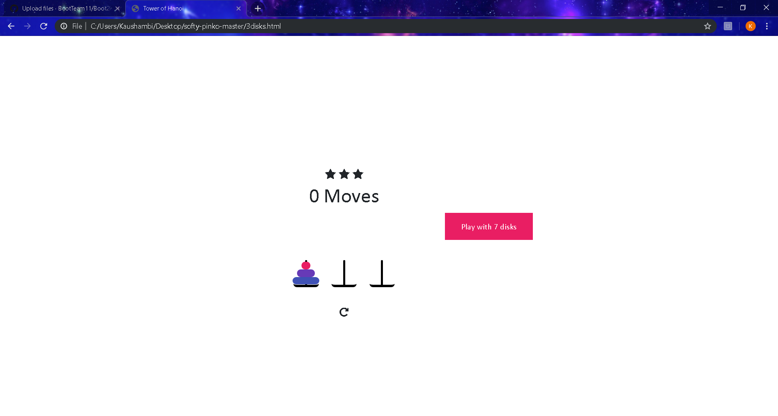 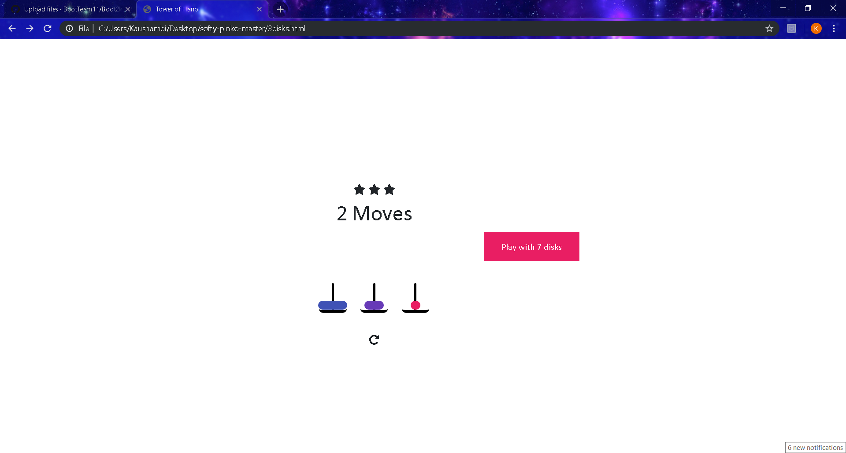

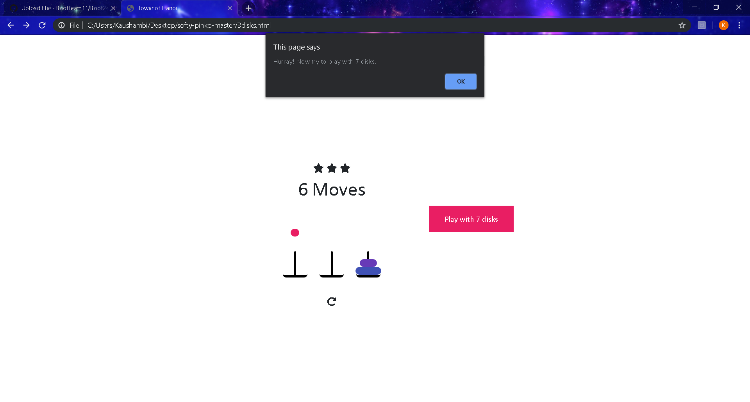

3.3 Similarly play the Puzzle with 7 Disks:

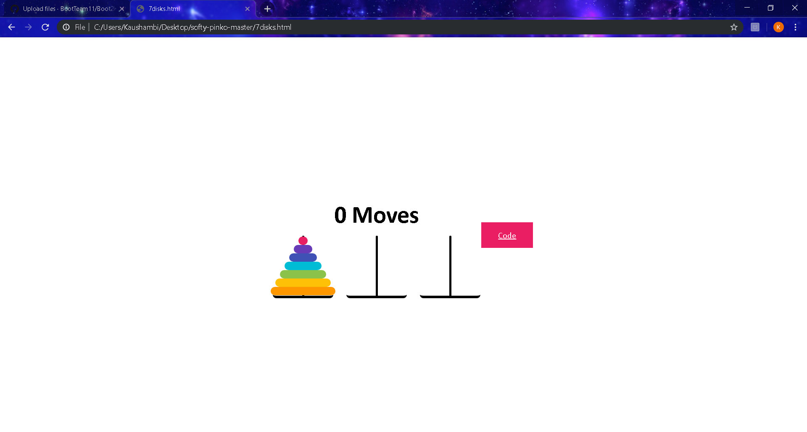3.4 Proceed to Code:



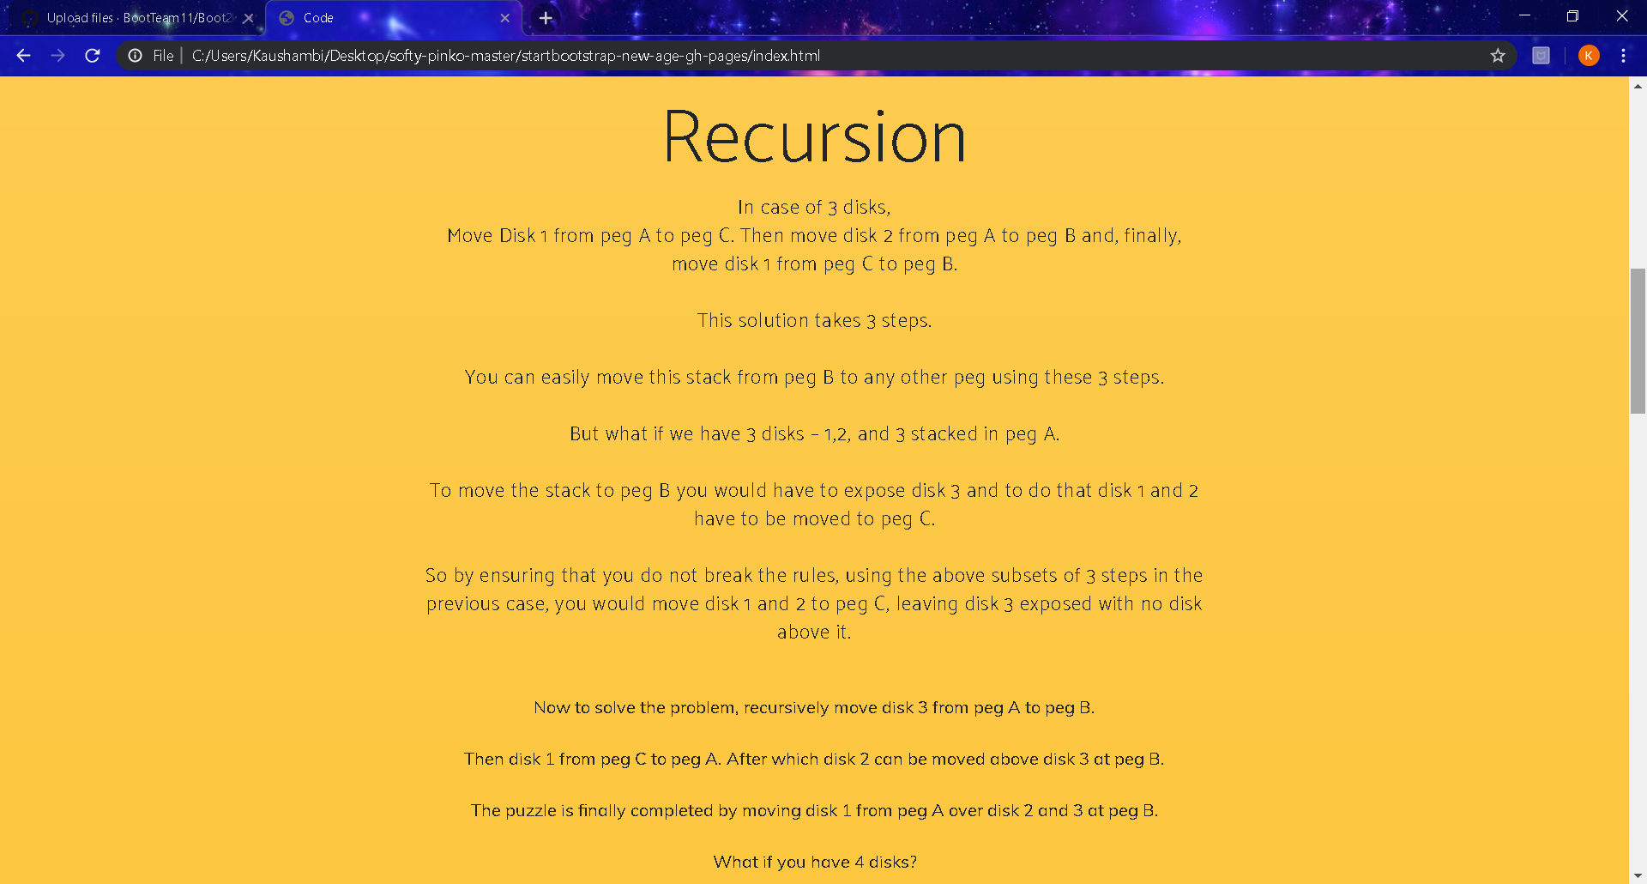



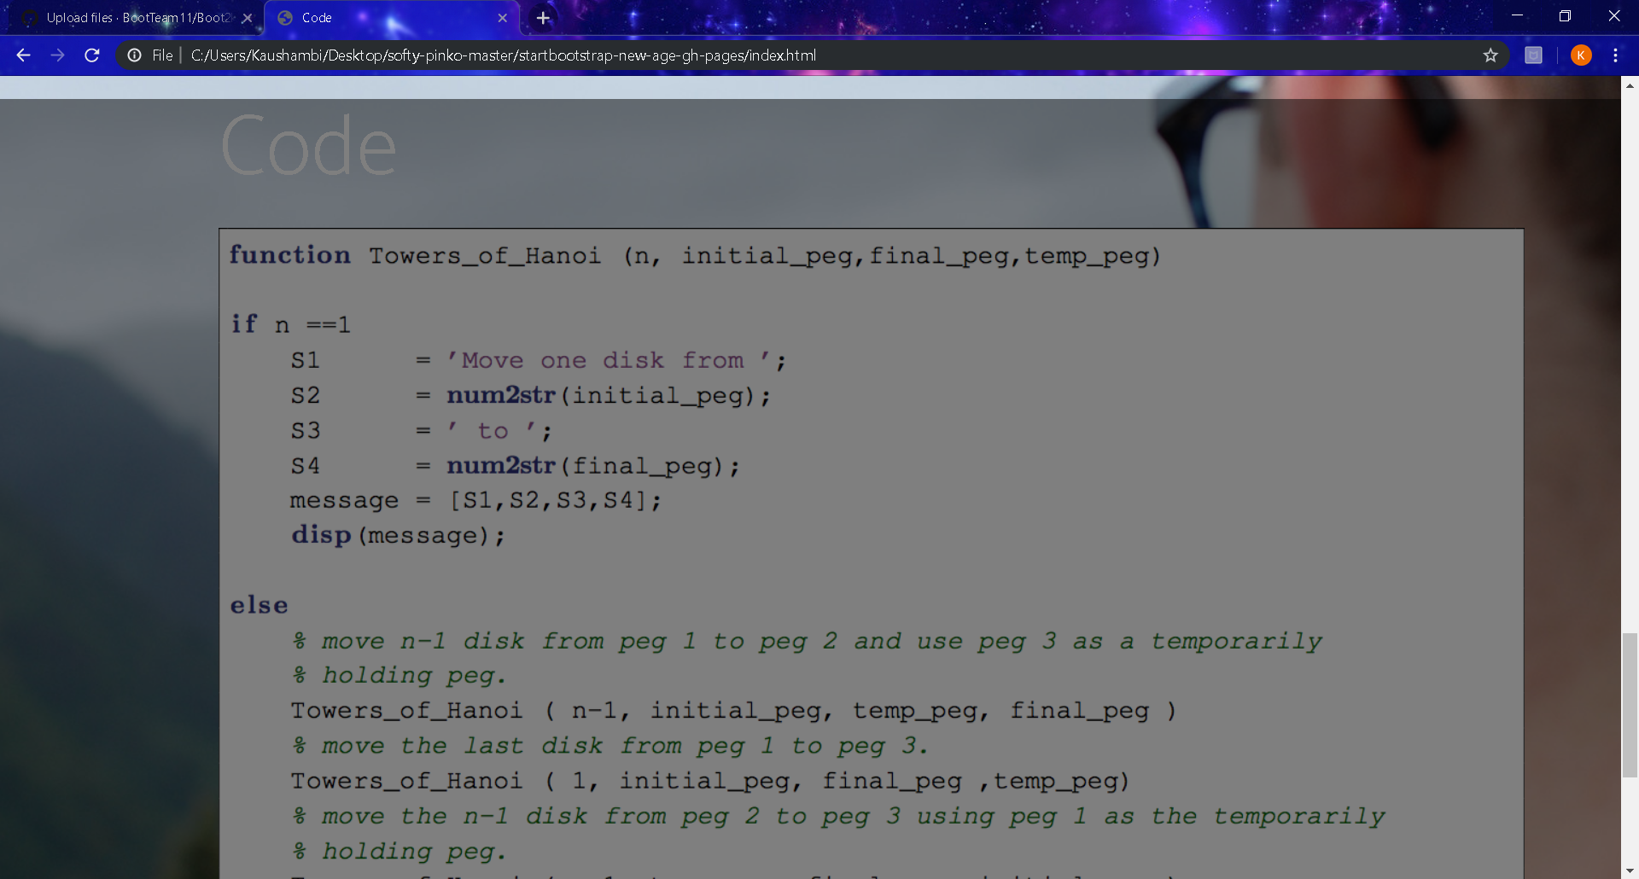

3.5 Proceed to Quiz Questions

**4.Pre test Assessments** *(Highlight the correct option with bold text)*

1. What is the name of the equation that is used to solve this puzzle?

1. Geometric Progression

b. Arithmetic Progression

c. Fibonacci Sequence

1. **Recurrence Relation (Correct answer )**

2.The Tower of Hanoi has many useful applications.It is used in which of the following fields :

a.Computer Programming and Algorithms

b.Psychological Research

c.Data Backup rotation scheme

d.All of these

**5**.**Post test Assessments** *(**Write least one question for each learning objective from round 1)*

For Learning Objective 1

* 1. What is the number of moves required to solve Tower of Hanoi problem for k disks?

1. 2k-1

b.2k+1

c.2^k+1

bd.2^k-1

For Learning Objective 2

* 1. Tower of Hanoi problem can be solved iteratively
     1. True
     2. False

3.The optimal Data Structure used to solve Tower of Hanoi is:

a.Tree

b.Priority Queue

c.Heap

d.Stack

Copyright 2018-19, Virtual Labs - IIT Bombay.